Brand Guideline — Before & After
Your brand, your account setup, and your monthly plan
Social Media Marketing – Short & Practical · Instructor: Ahmad Hamed Ahmad
Fill in your OLD brand first, then your NEW brand, your account setup, and your monthly plan. This is what you'll show CAPA.
Brand name: Cheapify
____________________________________________________________
✗ BEFORE — Your Old Brand
Paste your old profile screenshot and old logo, then note your old look.
None | None
Old profile (screenshot) | Old logo
Old colours / look: None
____________________________________________________________
What was missing or weak: Brand does not exist
____________________________________________________________
✓ AFTER — Your New Brand
1 New Basics
What you sell (product / service): Digital solution | A multi-seller marketplace
____________________________________________________________
Your offer in ONE sentence: Cheapify collects many sellers, having all products in one place, with a smart techniques for listing all identical product from different sellers under one listing, offering side by side price comparison giving the buyers cheapest and best price options, offering trust and reliability.
____________________________________________________________
Brand voice — 3 words: smart, transparent, reliable.
________________________________________
2 Your New Logo

Describe your new logo (icon, style): A modern blue shopping bag icon featuring an upward arrow and green magnifying glass, representing smart deal discovery and price savings
____________________________________________________________
3 Your New Colours
Colour the four boxes with your brand colours, then write the name or code (hex) under each.
Boston Blue  #0E82C4 | Jade Green  #148C53 | Charcoal  #292F33 | Cloud  #F6F8FA
Primary | Secondary | Dark | Light
4 Fonts (optional)
Heading font: Comfortaa(English) – IBM Plex(Arabic, Kurdish)
______________________________
Body font: Comfortaa(English) – IBM Plex(Arabic, Kurdish)
____________________________________
5 Your Platforms
Platform | Username / handle | What you post there | How often
Instagram | cheap.ify | Describing what cheapify is | 3 posts a week

6 Content Pillars
Pillar 1: Side-by-Side Price Comparisons & "Deal of the Day" spotlights (showing real price savings)
__________________________________________________________
Pillar 2: Local Verified Seller Spotlights (building buyer trust for participating shops)
__________________________________________________________
Pillar 3: Smart Shopping Tips & Customer Savings Proof (highlighting how buyers save time and money)
__________________________________________________________
7 Account Setup Checklist
Set your account up properly — tick each one when it's done.
Done Switch to a Business / Professional account.
Done Profile photo = your logo (clear and centred).
Done Username = your brand name (easy to search).
Done Bio: what you sell + who it's for + your city (1–2 lines).
☐ Contact buttons on: WhatsApp / call / email.
Done Link in bio: catalog, WhatsApp, or a link page.
☐ Highlights created: Products · Reviews · How to order.
☐ Product catalog / shop turned on (if you sell).
☐ Pin your 3 best posts to the top.
8 Monthly Content Plan (posts + captions)
Plan a month of content. Write the post idea, a draft caption, and the platform for each.
# | Day / date | Post idea | Caption (draft) | Platform
1 | Day 1 | Launch Teaser | The end of "DM for Price" is here. Introducing Cheapify: The bright side of choosing. Link in bio to browse the catalog. | Instagram / TikTok
2 | Day 3 | Merchant Spotlight | Meet [Pilot Shop Name], one of our first verified local sellers. Quality guaranteed, prices upfront. | Instagram / Facebook
3 | Day 5 | Feature Ed: Single SKU | Tired of duplicate listings? See how our smart app groups identical items so you instantly see the best deal. | Instagram Carousel / TikTok
4 | Day 8 | Side-by-Side Savings | Airpods Pro comparison. See the exact IQD savings when you choose the top-ranked seller on our Web Catalog. | Instagram / Facebook
5 | Day 10 | Behind the Shield | How we vet our sellers. Only trusted merchants make it to the Cheapify catalog. No scams, just verified shops. | Instagram / TikTok
6 | Day 12 | Order via WhatsApp | Found a deal? Ordering is easy. Click, confirm via WhatsApp, and get it delivered locally. Zero friction. | Instagram / Facebook
7 | Day 15 | Deal of the Day | Today's smartest choice: [Product Name]. Ranked #1 for value by our algorithm. Check the catalog link! | Instagram Stories / Feed
8 | Day 17 | Local Delivery Partner | We integrate with the best couriers in Duhok/KRI. Your item goes from a verified seller to your door securely. | Instagram / Facebook
9 | Day 19 | Customer Proof | "Saved 15,000 IQD in 2 minutes." Real test orders are rolling in! Be the next smart shopper. | Instagram / TikTok
10 | Day 22 | Tech/Fashion Compare | Why pay more? Visual graphic showing an overpriced listing elsewhere vs. the Cheapify fair price. | Instagram / Facebook
11 | Day 24 | Merchant Call-Out | Are you a local shop owner? Stop paying huge app fees. Join Cheapify's Web Catalog today. Flat & low rates. | Instagram / Facebook
12 | Day 26 | Monthly Wrap-Up | The bright side of choosing is here to stay. Browse the top 5 deals of the month on our Web Catalog right now. | Instagram / TikTok

TIP: Aim for about 3 posts a week. Batch-write your captions in one sitting, then you're set for the whole month.

9 Your Profile Grid — Before & After
Show how your profile page changed. Paste your OLD grid, then plan your NEW first 9 posts so the page looks cohesive and on-brand.
✗ BEFORE — your old profile grid
Paste a screenshot of your old profile, or old posts.
None | None | None
None | None | None
None | None | None

✓ AFTER — your new profile grid (first 9 posts)
Plan post 1 to 9 — sketch or note each one.
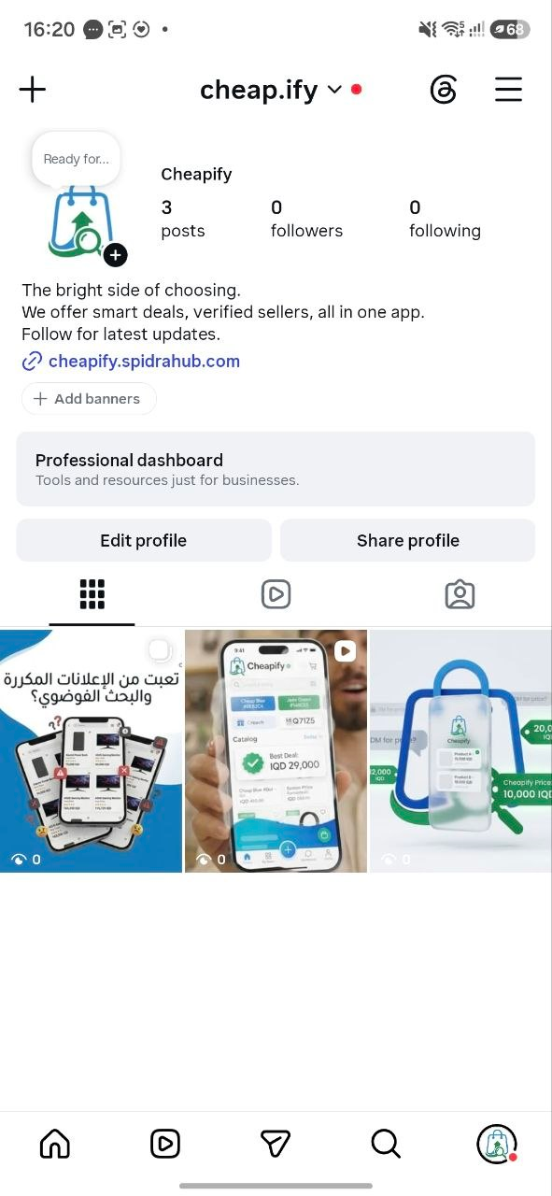
Not yet | Not yet | Not yet
Not yet | Not yet | Not yet

TIP: Alternate your pillars across the grid (product, tip, behind-the-scenes) and keep your colours consistent — that's what makes a profile look professional at first glance.

